# **7.5 Guided Exercise: Disabling Linux Services**

|  |  |
| --- | --- |
| **Resources** | |
| Files | None |
| Machines | Ubuntu Server |

In this exercise, you are required to disable the apache web server service.

On the Ubuntu Server run the command netstat –tulpn to confirm that the webserver is listening on port 80.

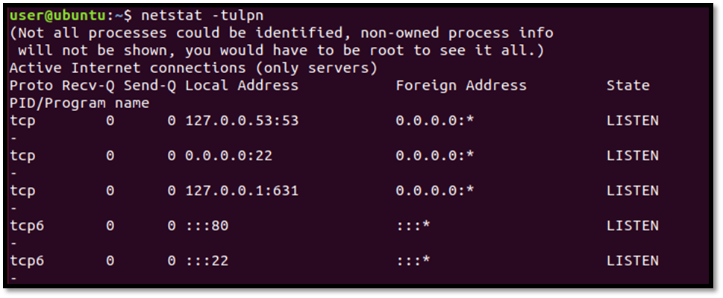  
Then run the command systemctl status apache2. Press the q button after the command shows the result.

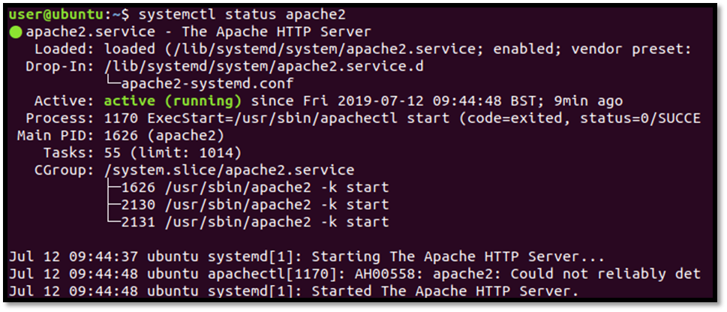

Then run the command systemctl stop apache2 to stop the service. Authentication is required so you need to enter the user password.



Run the systemctl status apache2 one more time to confirm that the apache2 service has been stopped.

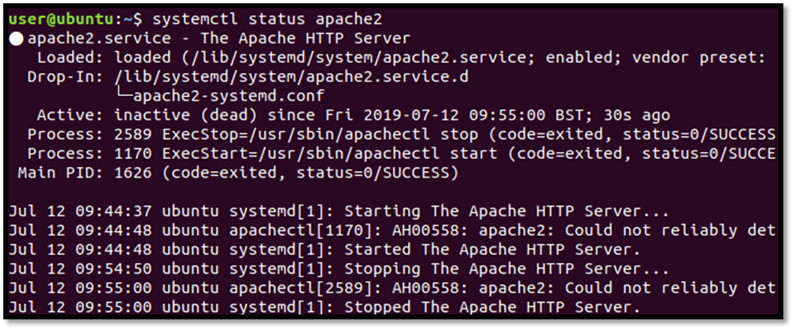

Run the command sudo systemctl disable apache2 to disable the webserver. The command requires the user password and enter Pa$$w0rd. That command will prevent the webserver from starting during boot time.

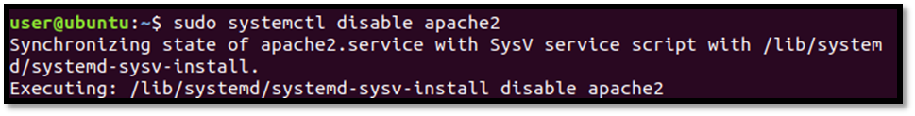

Run the command netstat –tulpn to confirm that port 80 is not listening for connections.

